**Final Practical Exam Worksheet**

**Student Name**: Sahil Kaundal **UID:** 21BCS8197

**Branch**: CSE(LEET) **Section/Group:** 807/B

**Semester**: 4th **Date of Performance**: 21/05/2022

**Subject Name**: CN Lab **Subject Code:** 20CSP-257

**Q1.**

1. **Aim/Overview of the practical:**

Create network to implement TCP/IP protocol.

1. **Task to be done/ Which logistics used:**

Create network to implement TCP/IP protocol.

TCP/IP stands for Transmission Control Protocol/Internet Protocol and is a suite of communication protocols used to interconnect network devices on the internet. TCP/IP is also used as a communications protocol in a private computer network (an [intranet](https://www.techtarget.com/whatis/definition/intranet) or extranet).

The entire IP suite -- a set of rules and procedures -- is commonly referred to as TCP/IP. [TCP](https://www.techtarget.com/searchnetworking/definition/TCP) and [IP](https://www.techtarget.com/searchunifiedcommunications/definition/Internet-Protocol) are the two main protocols, though others are included in the suite*.*The TCP/IP protocol suite functions as an abstraction layer between internet applications and the routing and switching fabric.

1. **Apparatus/Simulator used** **(For applied/experimental sciences/materials-based labs):**

Cisco Packet Tracer

Generic Router

Switch

End Devices.

1. **Steps:**

**Step 1:** Create a system using routers, switches and different end devices.

**Step 2:** Connect all the end- devices with switch.

**Step 3:** Connect router with each other.

**Step 4:** Assign IPs to all devices.

**Step 5:** Drop Packet and start simulation.

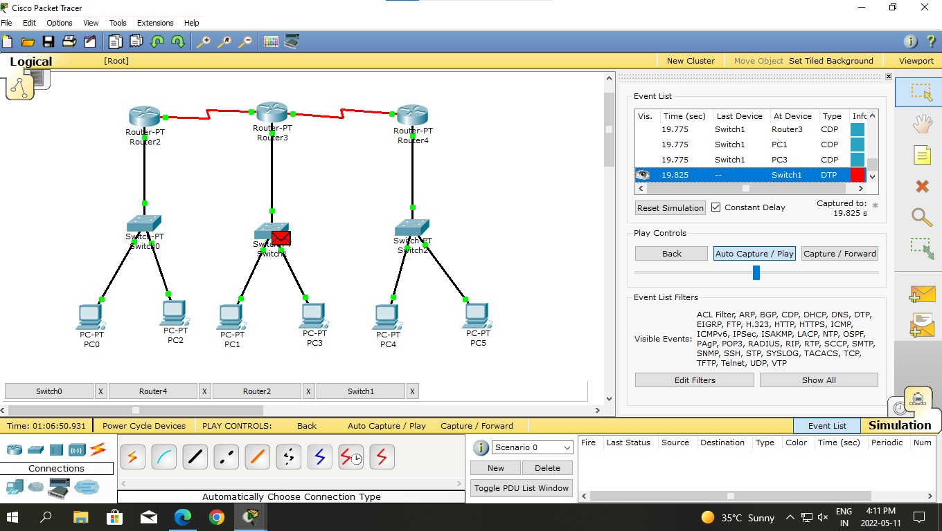

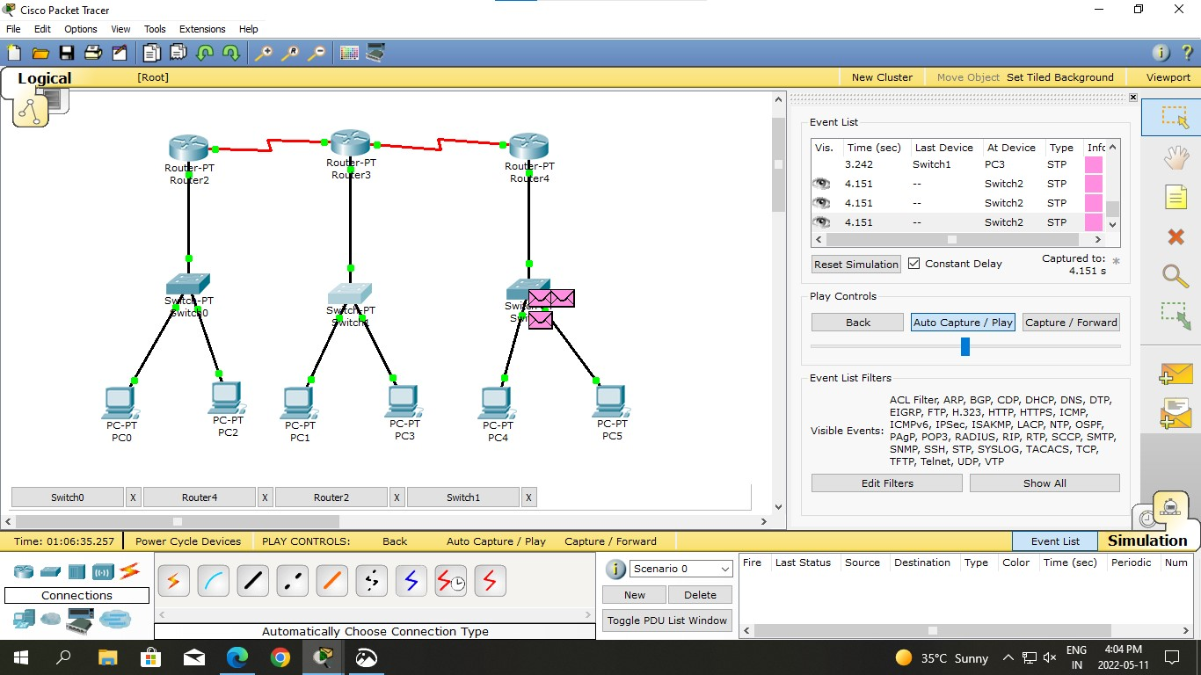

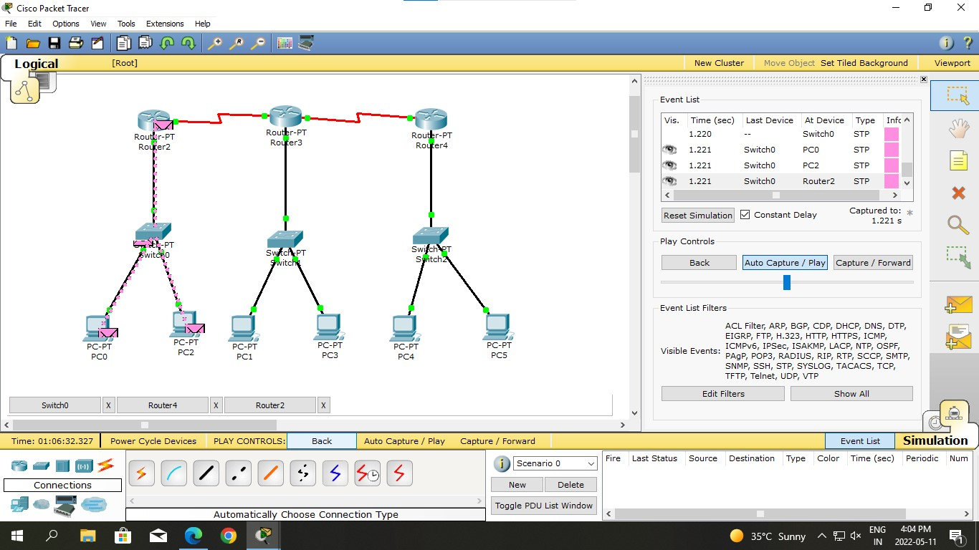

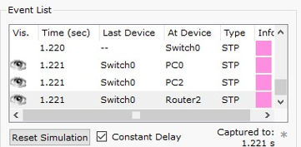

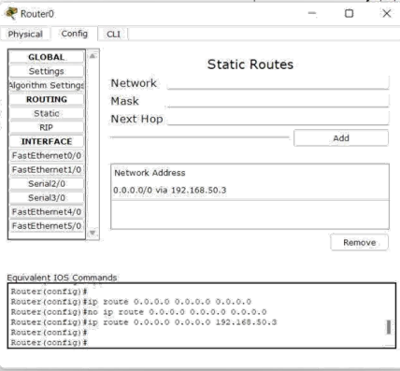

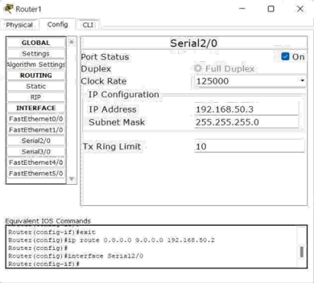

**Q2.**

1. **Aim/Overview of the practical:**

Create a network using Distance Vector routing Protocol using Packet Tracer.

1. **Task to be done/ Which logistics used:**

We need to send PDU from one end device to another end device with the help of router having different networks.

1. **Apparatus/Simulator used** **(For applied/experimental sciences/materials-based labs):**

Cisco Packet Tracer

1. **Algorithm/Flowchart** **(For programming-based labs):**

1. Open the simulator.

2. Plot some generic routers and some end devices (PC’s) where end devices to router is connected by Automatically Chosen wire and routers are connected each other by Serial DCE wire type.

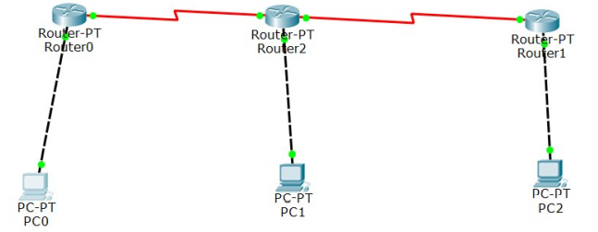

3. Give Ip addresses to all the end devices and give default Ip address to router with default gateway

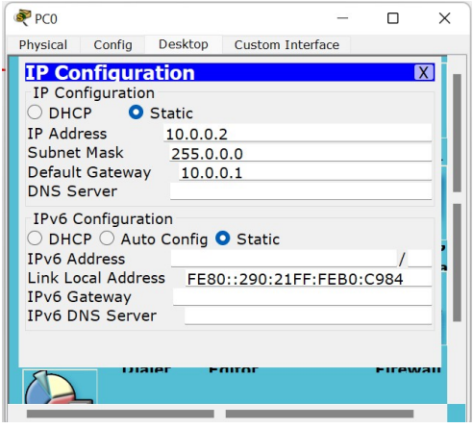

4. Now, Configure router’s fast ethernet with port status ON

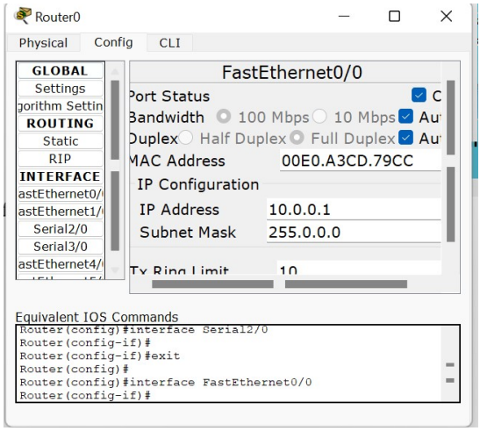

5. Now, configure router’s serial port with clock rate 64000 and port status ON

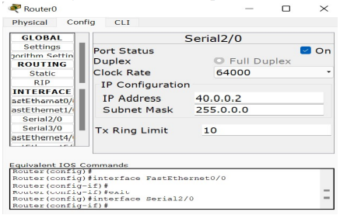

6. Now, configure static routing of router

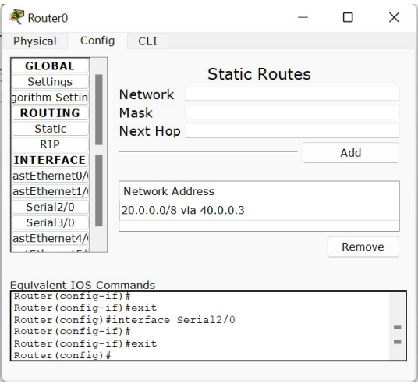

7. Also, now similarly setup other routers and end devices for perfect setup for experiment. And make sure all connections are green.

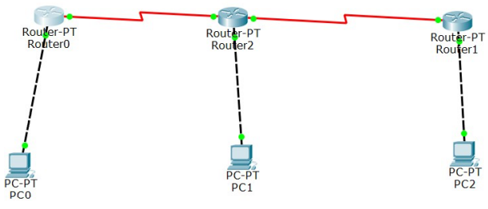

8. Now, run stimulation in real time by PDU.

9. Now, check successful status.

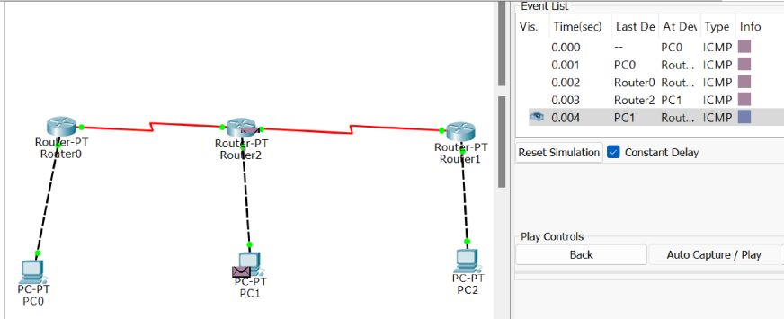

10. Now stop stimulation after successful output for experiment.

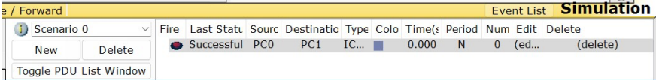

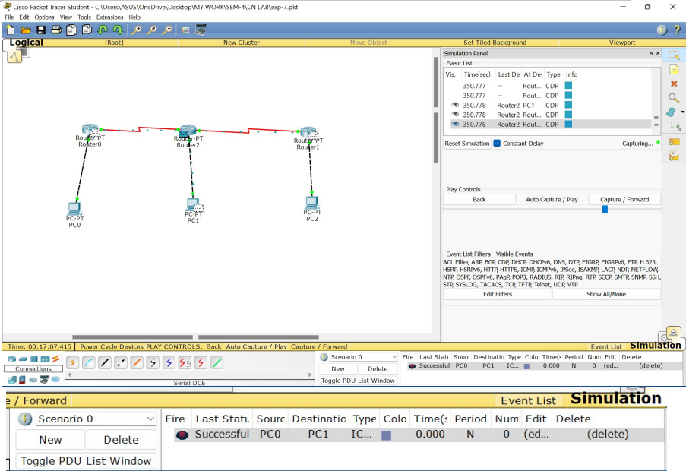

**Result: -**

I have successfully completed this experiment.

**Evaluation Grid (To be created as per the SOP and Assessment guidelines by the faculty):**

|  |  |  |  |
| --- | --- | --- | --- |
| Sr. No. | Parameters | Marks Obtained | Maximum Marks |
| 1. |  |  |  |
| 2. |  |  |  |
| 3. |  |  |  |
|  |  |  |  |